6CS007 Project and Professionalism
Final Year Project
Mid-Year Report

SkillLantern: Career Recommendation System

Student Name: Saurav Shrestha
Student ID: 2408619
Supervisor: Mrs. Prakriti Regmi
Reader: Mr. Simon Giri
Table of Contents
1. Project Overview 1
1. Work Completed So Far 2
1.1. Literature Review / Background Research 2
1.2. Requirements Gathering & Analysis 5
Functional Requirement (FR) and Non-Functional Requirement (NFR) 6
1.3. Design 8
System Architecture Diagram: 8
Use Case Diagram: 9
User Persona 1: 9
User Persona 2: 9
Activity Diagrams: 10
Sequence Diagrams: 13
Entity Relationship (ER) Diagram: 14
Class Diagram: 15
1.4. Implementation 15
1.5. Testing 17
2. Technology Stack / Tools Used 18
3. Progress Showcase 19
4. Challenges Faced 26
5. Remaining Work 26
6. Timeline for Completion (Gantt Chart) 27
7. Risk Assessment and Mitigation 27
8. Supervisor Meetings Summary 28
9. Self-Assessment 29

Project Overview
The project addresses the lack of accessible, data-driven career counselling services available to students and early-career professionals in Nepal. The primary aim is to deliver a practical, AI-powered career guidance platform that analyses a user's comprehensive profile — including academic background, technical and soft skills, areas of interest, certifications, CGPA, and career lifestyle preferences — and provides personalised career recommendations, structured learning roadmaps, and college suggestions tailored to the Nepalese context.
The motivation is grounded in the societal and structural challenges faced by Nepalese students, where professional career counselling is scarce and students frequently rely on informal advice from family, peers, or social media. The project therefore prioritises a hybrid AI approach combining machine learning classification with natural language generation to provide both quantitative career predictions and qualitative, actionable guidance.
Objectives:
- Develop a machine learning classification model using XGBoost trained on survey data from Nepalese graduates, capable of predicting suitable career categories based on a user's academic background, skills, and interests.
- Integrate a locally hosted large language model (LLaMA 3 via Ollama) for generating personalised career roadmaps, college recommendations, and career summaries through natural language generation.
- Design and implement a full-stack web application with a responsive, multi-step user registration flow that captures comprehensive user profile data for accurate career assessment.
- Curate and integrate a dataset of Nepalese educational institutions, enabling the system to recommend colleges and programmes relevant to the user's predicted career path, location preference, and budget.
- Implement a rule-based fallback prediction system that provides baseline career recommendations when the machine learning model is unavailable, ensuring system reliability.
- Evaluate the machine learning model using established classification metrics (accuracy, precision, recall, F1-score, top-k accuracy, confusion matrices) through stratified cross-validation and held-out test set evaluation.
Expected Outcomes:
- A working web application that accepts comprehensive user profile data through a multi-step registration form and returns personalised career recommendations via a dashboard.
- A FastAPI backend API that performs feature encoding, XGBoost model inference, LLaMA 3-powered roadmap generation, and college recommendations from a curated Nepalese dataset.
- A hybrid AI architecture combining an XGBoost classifier for career prediction with LLaMA 3 for natural language content generation, with a rule-based fallback for system reliability.
- A documented evaluation framework with classification metrics, confusion matrices, cross-validation results, and feature importance analysis.

Work Completed So Far
At the mid-year stage, the project has progressed through literature analysis, requirements definition, system design, and the implementation of a functioning prototype spanning the machine learning model layer, FastAPI backend services, Next.js web frontend, and database integration. Testing activities have begun, with emphasis on integration correctness and early model evaluation. Comprehensive quantitative evaluation is scheduled for the remaining project period and is described with appropriate placeholders.

Literature Review / Background Research
The background research reviewed contemporary approaches to career recommendation systems, including classical machine learning pipelines (Random Forest, SVM, Naive Bayes), gradient boosting methods (XGBoost, LightGBM, CatBoost), and the application of large language models in educational contexts. The literature indicates that gradient boosting models — particularly XGBoost — dominate structured/tabular data classification tasks, consistently outperforming both traditional ML classifiers and deep learning approaches on tabular benchmarks. However, recurring limitations were identified: limited personalisation in generated guidance, lack of context-aware recommendations for specific regional job markets, and the absence of systems that combine structured ML prediction with natural language generation.
The review also considered existing career guidance platforms (LinkedIn Career Explorer, CareerExplorer/Sokanu, MyNextMove, Roadmap.sh, Shiksha.com) and identified gaps: none provide AI-powered, personalised career guidance specifically tailored to the Nepalese educational system and job market. This motivated the development of Skill Lantern as a Nepal-specific career guidance system.
Key conclusions informing project direction:
- XGBoost is the most appropriate algorithm for career prediction on structured survey data, offering regularisation, native multi-class support, and superior performance on tabular benchmarks.
- A hybrid ML+LLM architecture addresses the limitation that ML classifiers produce only discrete predictions without personalised, actionable guidance.
- Feature engineering — particularly multi-label binarisation for skills and interests — significantly impacts prediction quality.
- Local LLM deployment (LLaMA 3 via Ollama) avoids cloud API costs and privacy concerns, making it suitable for a student project.
- A rule-based fallback system ensures recommendations are always available, even when the ML model is unavailable.
Summary Table of Reviewed Papers and Design Implications:
Paper | Method | Dataset(s) | Key Results | Limitations | How it informs this project
Garg & Sharma (2021) – Career Rec. System | Random Forest, Decision Trees, SVM on student data | Student academic & skills data | Ensemble methods (Random Forest) outperform single classifiers; accuracy >90% | Limited to traditional classifiers; no NLG component | Validates ML for career guidance; supports choice of XGBoost as advanced ensemble method
Mohamed et al. (2022) – Student Career Prediction | Naive Bayes, KNN, Random Forest with feature engineering | Academic performance & skills data | Multi-label binarisation of skills significantly improves prediction quality | No personalised guidance generation; limited feature encoding | Directly informed Skill Lantern's feature engineering pipeline (top-50 skills binarisation)
Chen & Guestrin (2016) – XGBoost | Gradient boosted decision trees with regularisation | Multiple benchmarks | State-of-the-art for tabular data; efficient sparse data handling | May overfit on small datasets without proper regularisation | Core algorithm for Skill Lantern's career prediction model
Touvron et al. (2023) – LLaMA | Open-source foundation language model | Large text corpus | Competitive with larger models; suitable for local deployment | Requires significant RAM; not designed for classification tasks | Basis for Skill Lantern's NLG component via local Ollama deployment
Sharma & Kumar (2020) – Career Counselling Expert System | Hybrid ML + rule-based reasoning | Career counselling data | Hybrid systems more robust than either approach alone | Limited scalability; rule maintenance overhead | Motivates Skill Lantern's XGBoost + rule-based fallback architecture
Nie et al. (2022) – Rec. Systems in Education | Survey of collaborative, content-based, and hybrid approaches | Survey (multiple studies) | Educational recommendations must account for learning progression and constraints | Survey-level guidance; limited deployment detail | Informed 3-stage roadmap design (Beginner→Intermediate→Advanced)
Bhalke & Doifode (2023) – AI-Based Career Guidance | ML classification for Indian students | Survey-based career data | Validates survey-based career prediction in South Asian context | No NLG for roadmaps; simpler classification model | Validates approach; highlights novelty of Skill Lantern's hybrid ML+LLM architecture

Requirements Gathering & Analysis
Requirements were derived from the project objectives and from usability considerations for students and early-career professionals seeking career guidance in Nepal. The requirements emphasise comprehensive profile capture, clarity of AI-generated outputs, and responsible presentation of prediction confidence. Functional requirements focus on career prediction, roadmap generation, and college recommendation capabilities. Non-functional requirements focus on response time, reliability, privacy, and maintainability.
Functional requirements (defined and partially implemented):
- Accept comprehensive user profile data via a multi-step registration form (personal info, education, skills, interests, certifications, preferences).
- Predict suitable career categories using the XGBoost model and return top-k predictions with confidence scores.
- Provide a rule-based fallback prediction when the XGBoost model is unavailable, using a skill-to-career mapping dictionary.
- Generate a three-stage career roadmap (Beginner, Intermediate, Advanced) using LLaMA 3 via Ollama.
- Recommend Nepalese colleges relevant to the predicted career, filtered by location, budget, and degree level.
- Provide a comprehensive recommendation endpoint that orchestrates career prediction, roadmap generation, college recommendations, and summary generation.
- Support user authentication with secure login and registration via NextAuth.js v5.
- Display all recommendations on an interactive dashboard with progressive disclosure.
Non-functional requirements:
- Career prediction API responses within 2 seconds; full recommendation (including LLM generation) within 60 seconds.
- Secure password handling using bcryptjs hashing and encrypted JWT session tokens.
- Privacy-aware processing — user data stored in PostgreSQL with proper access controls.
- Maintainability through modular separation between frontend, backend, ML model, and LLM services.
- CORS configuration for secure frontend-backend communication.

Functional Requirement (FR) and Non-Functional Requirement (NFR)
Req ID | Requirement | Type | Priority | Implementation Status
FR-01 | Accept user profile data via multi-step registration form (6 steps: personal info, education, skills, interests, certifications, preferences). | Functional | High | Completed
FR-02 | Predict career categories using XGBoost model and return top-k predictions with confidence scores. | Functional | High | Completed
FR-03 | Provide rule-based fallback prediction when XGBoost model is unavailable using skill-to-career mapping (50+ skills). | Functional | High | Completed
FR-04 | Generate 3-stage career roadmap (Beginner, Intermediate, Advanced) using LLaMA 3 via Ollama. | Functional | High | Completed
FR-05 | Recommend Nepalese colleges filtered by location, budget, and degree level from curated dataset (~1,400 institutions). | Functional | High | Completed
FR-06 | Provide full recommendation endpoint orchestrating prediction, roadmap, colleges, and summary. | Functional | High | Completed
FR-07 | Support user authentication (login/signup) with NextAuth.js v5 and credential-based auth. | Functional | High | Completed
FR-08 | Display career predictions, roadmap, and college recommendations on interactive dashboard. | Functional | High | Completed
FR-09 | Provide health check endpoint reporting API, Ollama, and model status. | Functional | Medium | Completed
FR-10 | Store user profiles, predictions, and recommendations in PostgreSQL via Prisma ORM. | Functional | High | Completed
FR-11 | Support career category browsing and career insights retrieval. | Functional | Low | Completed
NFR-01 | Career prediction API responds within 2 seconds; full recommendation within 60 seconds. | Non-functional | High | In progress
NFR-02 | Secure password storage using bcryptjs hashing; JWT-based session management. | Non-functional | High | Completed
NFR-03 | Handle invalid inputs and backend failures with clear, user-friendly error responses. | Non-functional | High | Completed
NFR-04 | Maintainability: keep ML inference, LLM services, API routes, and frontend modular. | Non-functional | Medium | Completed
NFR-05 | CORS configuration for frontend-backend communication security. | Non-functional | High | Completed
NFR-06 | Responsive UI that works across different screen sizes and devices. | Non-functional | Medium | In progress

Design
The system design follows a modular three-tier architecture, separating the user interaction layer (Next.js frontend) from the backend services (FastAPI) and the data/AI layer (XGBoost model, Ollama/LLaMA 3, PostgreSQL, CSV datasets). A hybrid AI design is adopted combining an XGBoost classifier for structured career prediction with LLaMA 3 for natural language generation of roadmaps, summaries, and college explanations. When the ML model is unavailable, a rule-based fallback ensures system reliability.
Design artifacts prepared:

System Architecture Diagram:
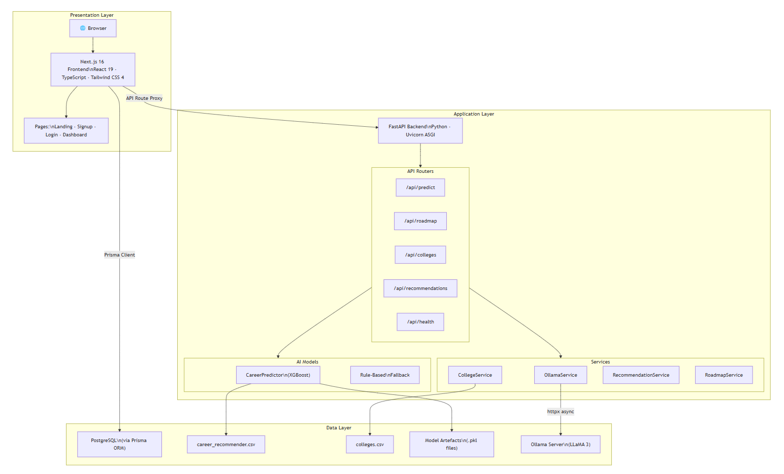

Use Case Diagram:
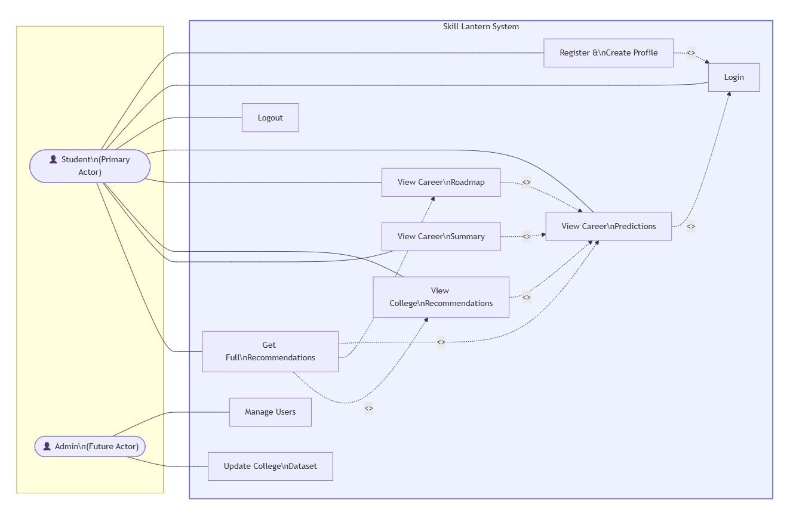

User Persona 1:
Name: Ram Sharma | Age: 21 | Background: Final year BSc CSIT student at Tribhuvan University, Kathmandu. Proficient in Python, JavaScript, and Machine Learning. Interested in AI and data science careers but unsure which specific career path to pursue. Has completed online certifications in Python and TensorFlow. Wants guidance on what skills to develop next and which colleges offer relevant master's programmes in Nepal.

User Persona 2:
Name: Sita Thapa | Age: 19 | Background: Second year BBA student at Pokhara University. Has soft skills in communication and leadership, interested in marketing and business management. No technical certifications. Looking for career direction and wants to know which careers match her business background and interests. Prefers working in Pokhara region.

Activity Diagrams:
1. User Registration and Profile Creation
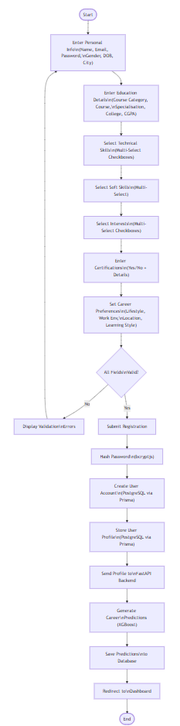
2. Career Recommendation Generation
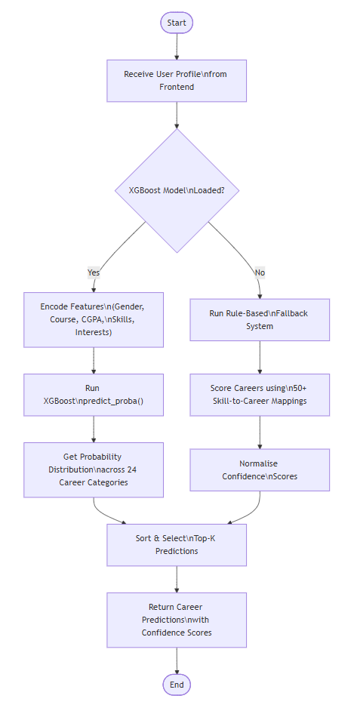
3. Full Recommendation Flow
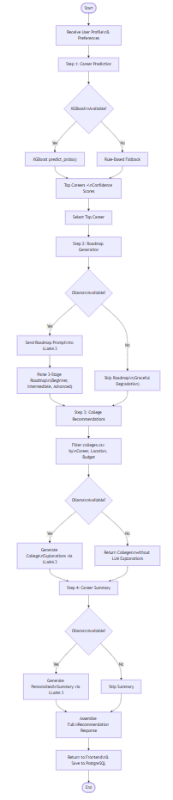

Sequence Diagrams:
1. Career Prediction Flow
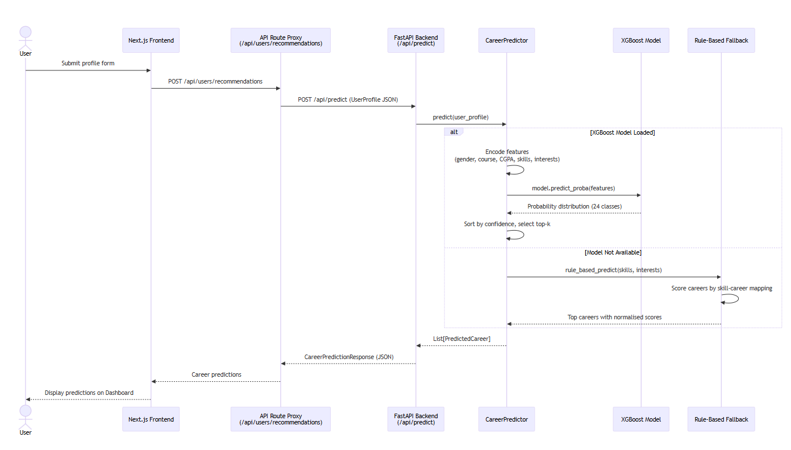
2. Full Recommendation Flow
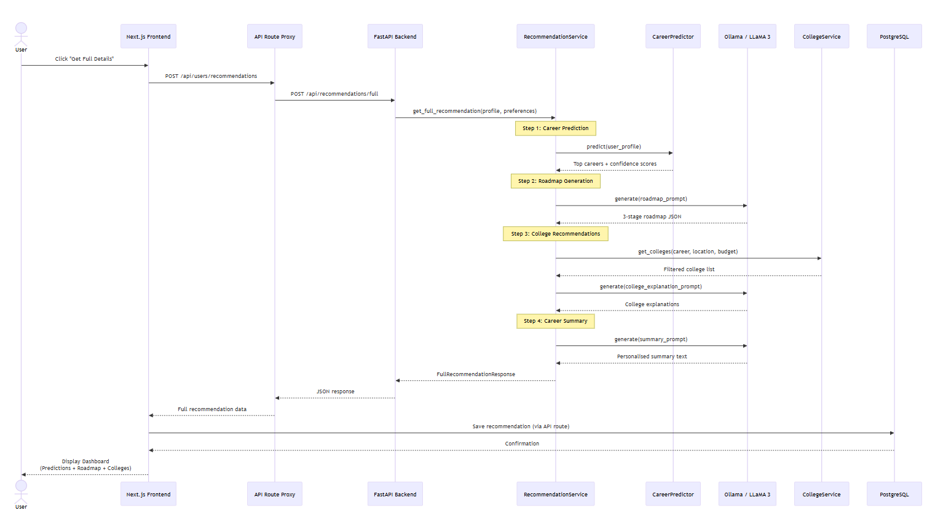

Entity Relationship (ER) Diagram:
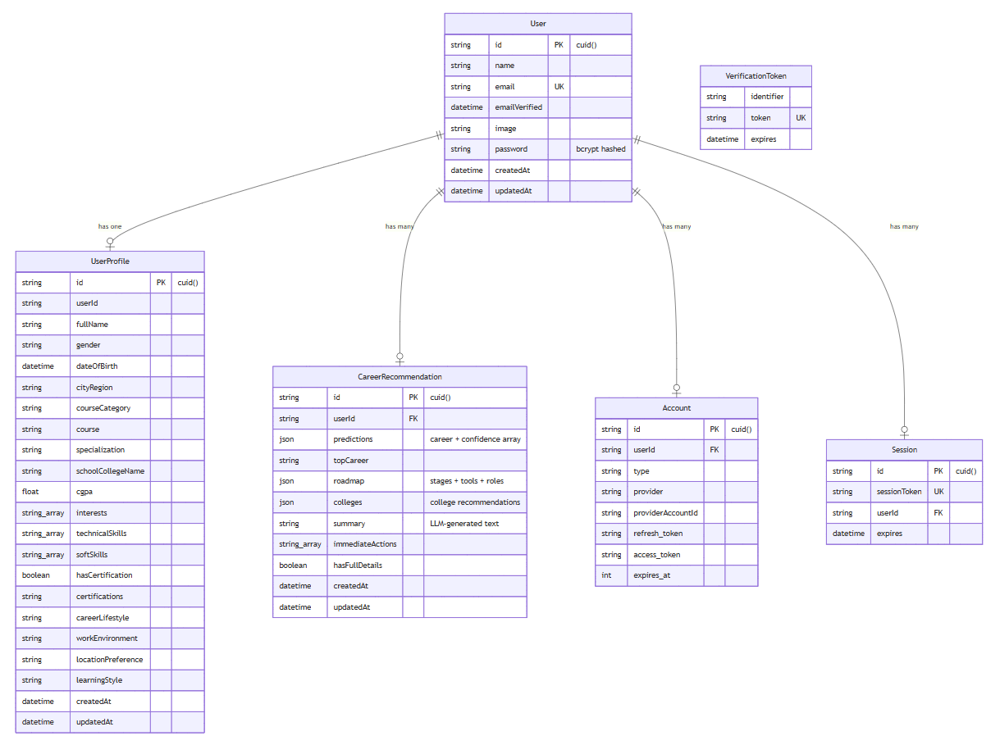

Class Diagram:
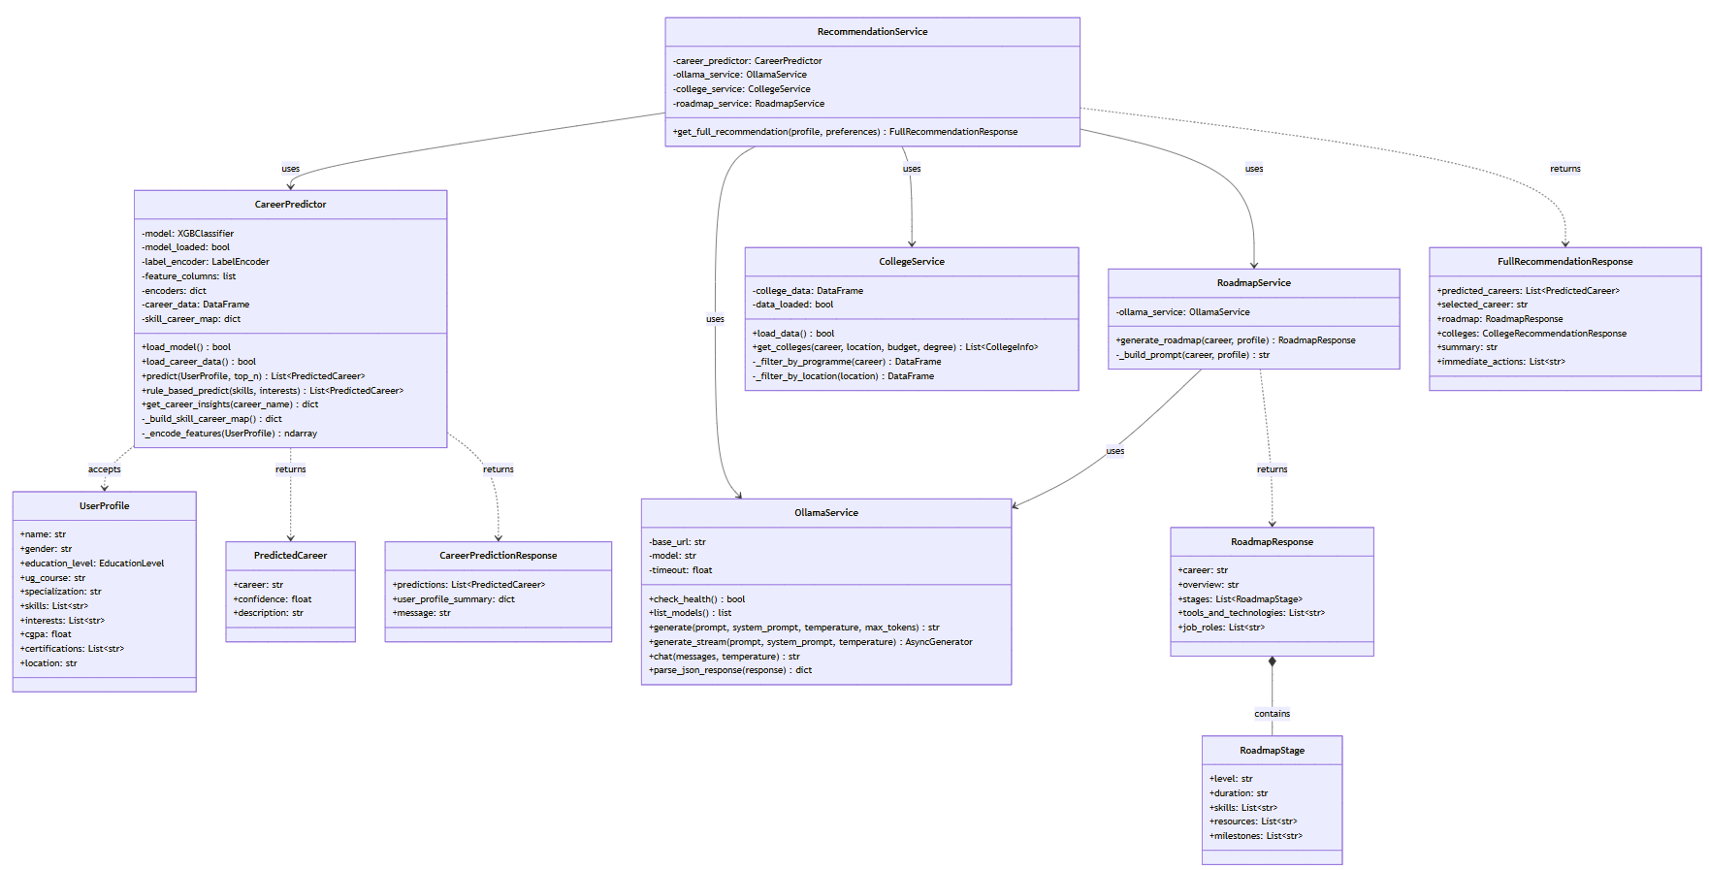

Implementation
- Set up development environment and version control (GitHub)
A dedicated GitHub repository was created with separate modules for the FastAPI backend and Next.js frontend. Environment configuration was externalised using .env variables, enabling reproducible local setup and consistent deployment configuration.
- Established project structure and coding standards
A modular structure was adopted to separate concerns: frontend UI components and pages (Next.js App Router), API route proxies, backend API routers (career.py, roadmap.py, colleges.py, recommendations.py), services (OllamaService, CollegeService, RecommendationService, RoadmapService), and the ML model module (CareerPredictor). Type safety was enforced via TypeScript on the frontend and Pydantic schemas on the backend. ESLint was configured for frontend code quality.
- Implemented core features:
Feature 1: XGBoost Career Prediction API
A POST /api/predict endpoint accepts user profile data (gender, education level, course, specialisation, CGPA, technical skills, soft skills, interests, certifications). The CareerPredictor module encodes features using label encoding for categorical variables and multi-label binarisation for skills/interests (top 50 skills, top 30 interests retained as binary features). The XGBoost model (500 estimators, max_depth=8, learning_rate=0.05) returns probability distributions across 24 career categories. Top-k predictions with confidence scores are returned. When the model is unavailable, a rule-based fallback using 50+ skill-to-career mappings provides baseline predictions.
Feature 2: LLaMA 3 Roadmap & Summary Generation
The system integrates Meta's LLaMA 3 via Ollama (local inference server) for natural language generation. Structured prompts are engineered to generate: (1) three-stage career roadmaps with duration estimates, skills to learn, resources, and milestones for each stage; (2) personalised career summaries tailored to the user's profile; (3) contextualised college explanations. Temperature-controlled sampling (temperature=0.5) governs creativity-determinism tradeoff. The OllamaService uses httpx for async HTTP communication.
Feature 3: College Recommendation System
The CollegeService loads and filters a curated dataset of ~1,400 Nepalese educational institutions (colleges.csv). Colleges are filtered by the user's predicted career, location preference, budget range, and degree level. LLaMA 3 generates contextualised explanations for why each college is recommended.
Feature 4: Full-Stack Web Application
A Next.js 16 web application with React 19 provides: a responsive landing page with Framer Motion animations, a multi-step signup form (6 steps capturing 15+ user attributes), NextAuth.js v5 credential-based authentication with bcryptjs password hashing, and an interactive dashboard displaying career predictions, roadmaps, and college recommendations. PostgreSQL via Prisma ORM stores user profiles, accounts, sessions, and recommendations.
- Database integration and CRUD operations
PostgreSQL integration via Prisma ORM was implemented for user persistence, including User, UserProfile, CareerRecommendation, Account, and Session models. The schema supports storing complex JSON data for predictions, roadmaps, and college recommendations. API routes handle profile creation, recommendation storage and retrieval, and session management.

Testing
Testing has commenced with emphasis on correctness of the end-to-end pipeline and reliability of the ML model and LLM integration under typical user inputs. The current stage focuses on smoke testing, integration testing across frontend and backend boundaries, and early model evaluation. A structured evaluation plan has been established for the final phase, including comprehensive metric reporting, cross-validation analysis, and confusion matrices.
Testing performed to date:
- Manual end-to-end testing of the complete user flow: registration → profile creation → career prediction → roadmap generation → college recommendations.
- Integration testing of API proxying between the Next.js frontend and the FastAPI backend.
- XGBoost model sanity checks: verifying prediction outputs, confidence score distributions, and feature encoding correctness.
- Ollama/LLaMA 3 integration testing: verifying prompt responses, JSON parsing of generated roadmaps, and error handling for Ollama unavailability.
- Rule-based fallback testing: verifying that predictions are returned when the XGBoost model is unavailable.
- Database CRUD testing: verifying user creation, profile storage, and recommendation persistence in PostgreSQL.
- Authentication flow testing: signup, login, session management, and protected route access.

Technology Stack / Tools Used
The technology stack was selected to support rapid iteration, reproducible experimentation, and reliable full-stack integration. The system combines modern web development frameworks with established machine learning tooling and local LLM inference.
Core technologies:
- Frontend: Next.js 16 (React 19) with TypeScript for a structured, component-driven user interface and API routing.
- Styling: Tailwind CSS 4 with shadcn/ui component library and Framer Motion for animations.
- Backend: FastAPI (Python) for an explicit, type-driven API layer with Pydantic schema validation.
- Machine Learning: XGBoost for multi-class career classification; scikit-learn for preprocessing and evaluation.
- Natural Language Generation: Meta's LLaMA 3 via Ollama for locally-hosted LLM inference.
- Database: PostgreSQL with Prisma ORM for type-safe database queries and automatic migrations.
- Authentication: NextAuth.js v5 with credential-based auth, bcryptjs password hashing, and JWT sessions.
- HTTP Client: httpx for async communication between FastAPI and Ollama.
- Data Processing: pandas, NumPy for feature engineering and data manipulation.
- Model Serialisation: joblib for saving/loading trained model artefacts (.pkl files).
Development and evaluation tools:
- Version control: Git with GitHub for collaboration and change tracking.
- IDE: Visual Studio Code with Python and TypeScript extensions.
- Package Managers: pip with virtualenv (Python backend) and npm (Next.js frontend).
- API Testing: FastAPI Swagger UI (/docs) for interactive API documentation and testing.
- Evaluation: scikit-learn metrics (accuracy_score, classification_report, confusion_matrix, cross_val_score, top_k_accuracy_score).
- Design Tools: Figma for wireframes and UI mockups.

Progress Showcase
This section summarises demonstrable progress artefacts from the prototype. The final submission will include screenshots, sample outputs, and representative user flows that validate the system's integration and usability.
Landing Page:
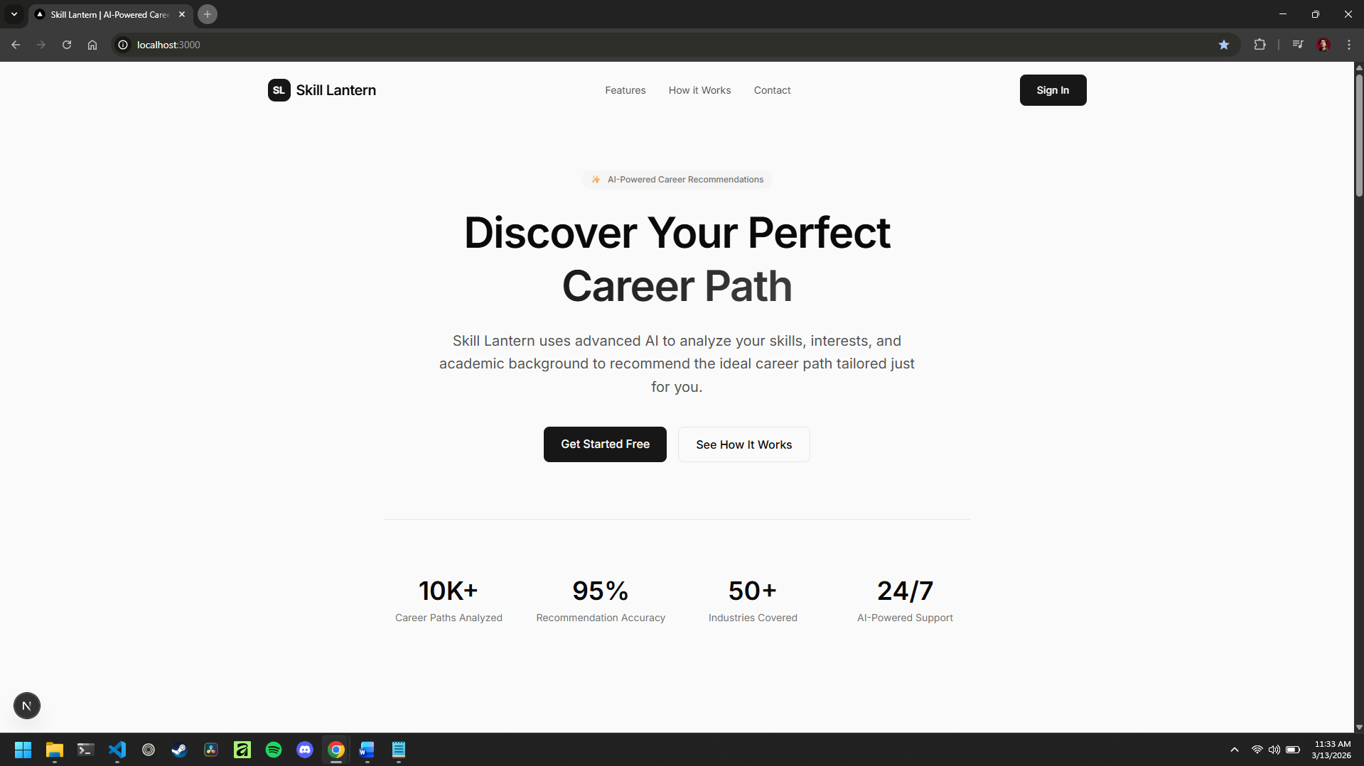
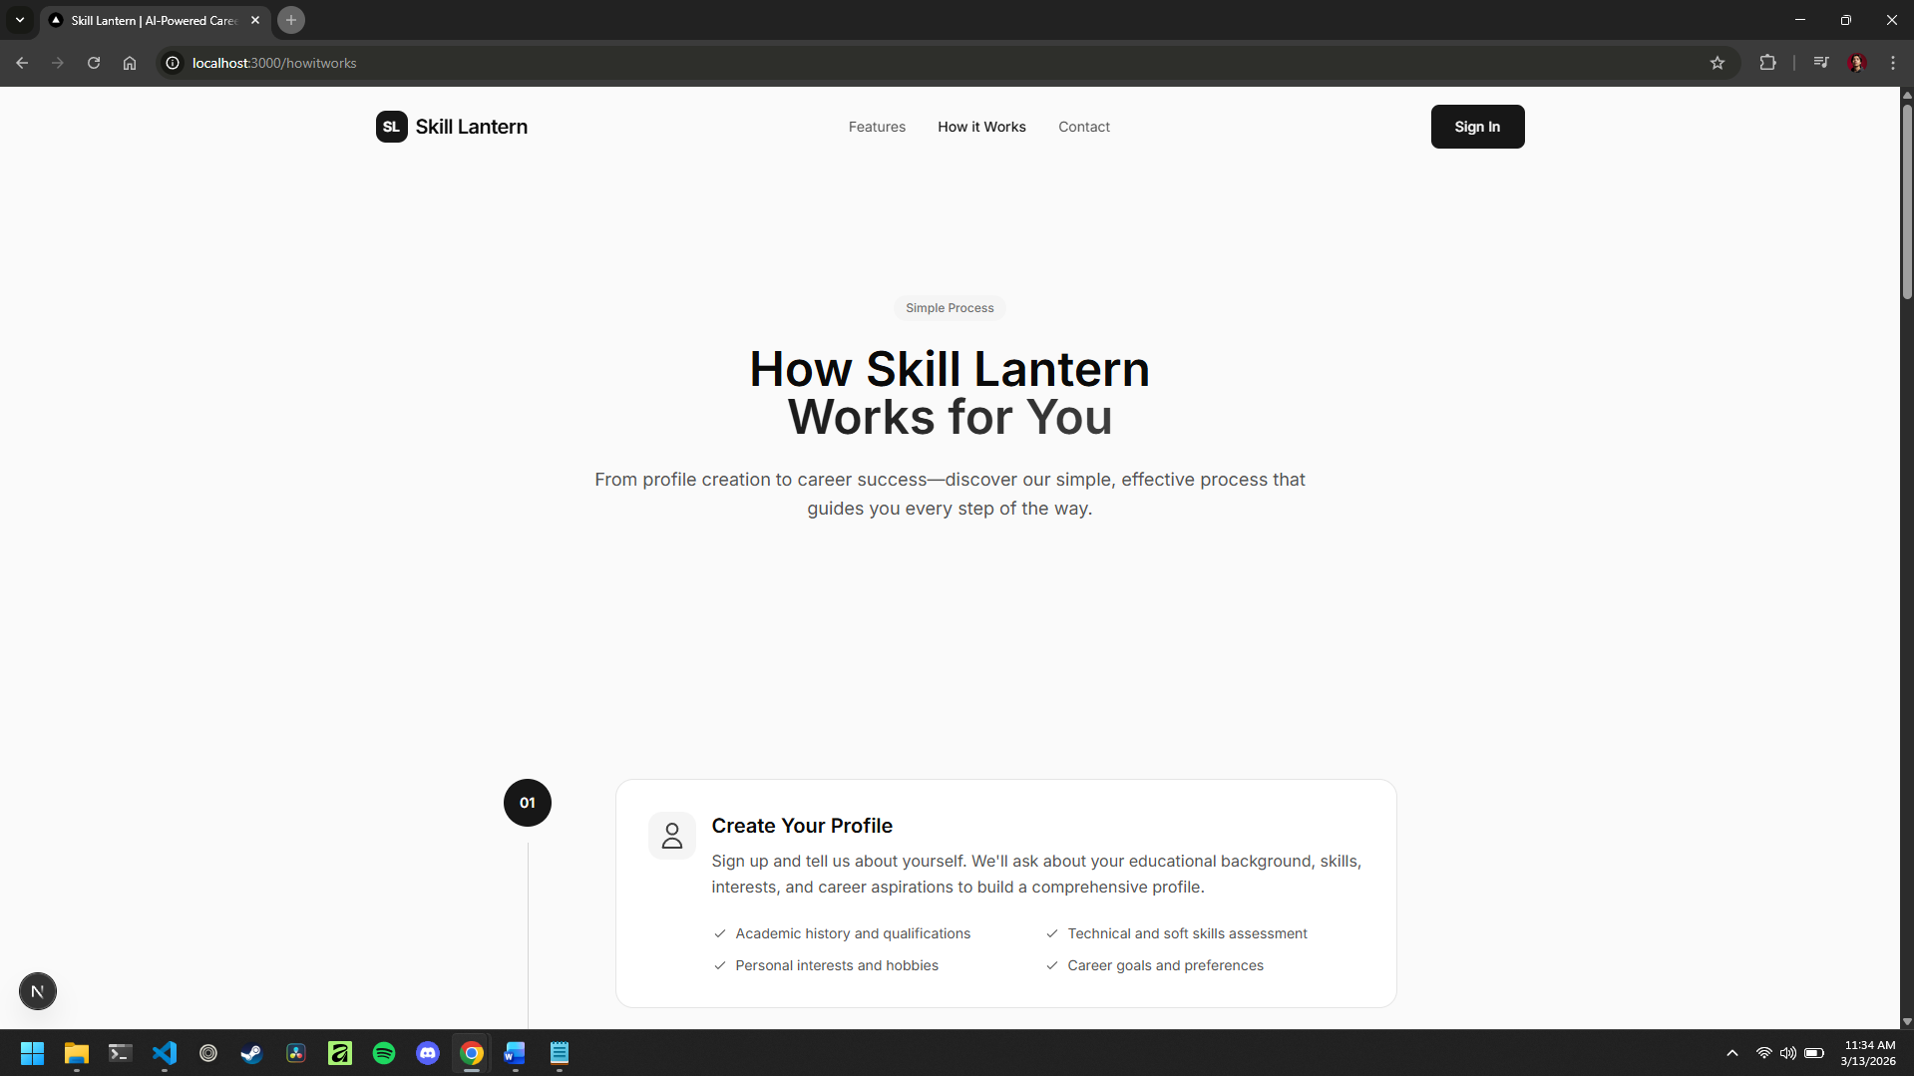

Signup Page (Multi-step Form):
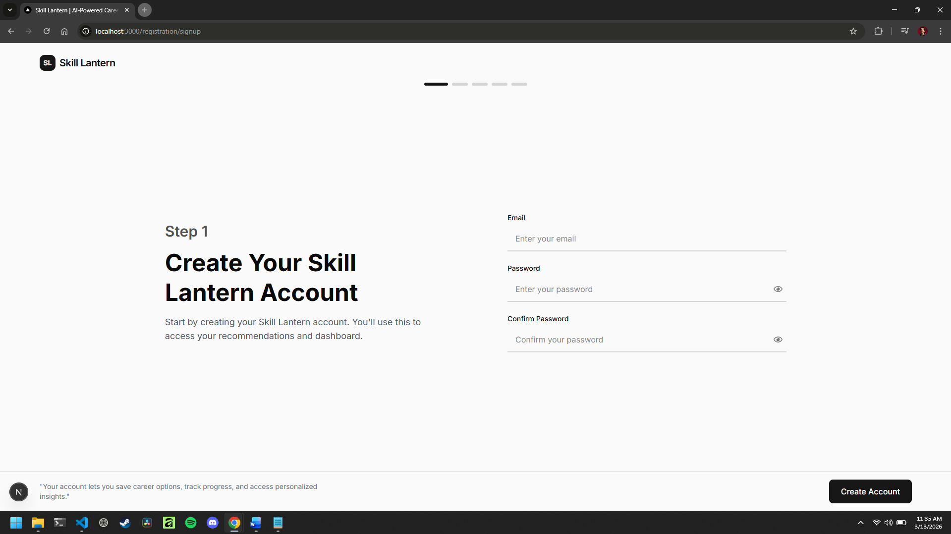
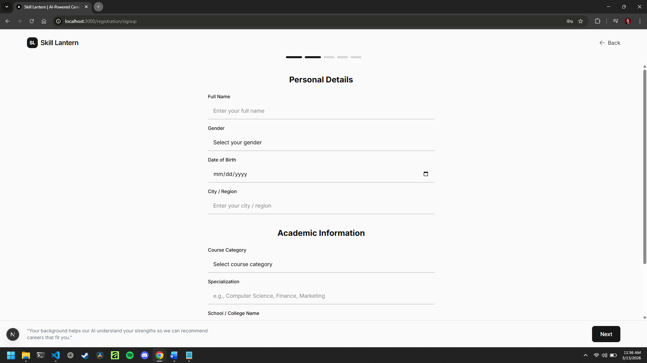
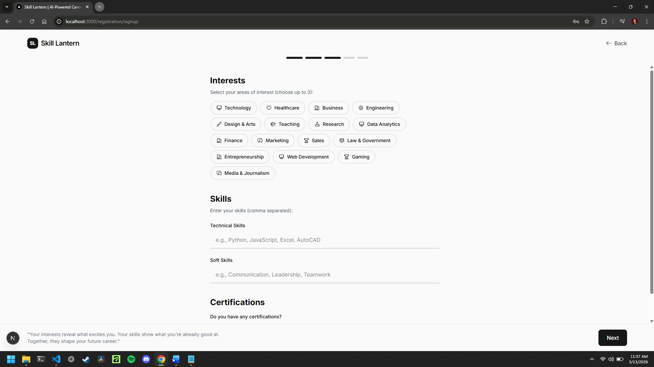
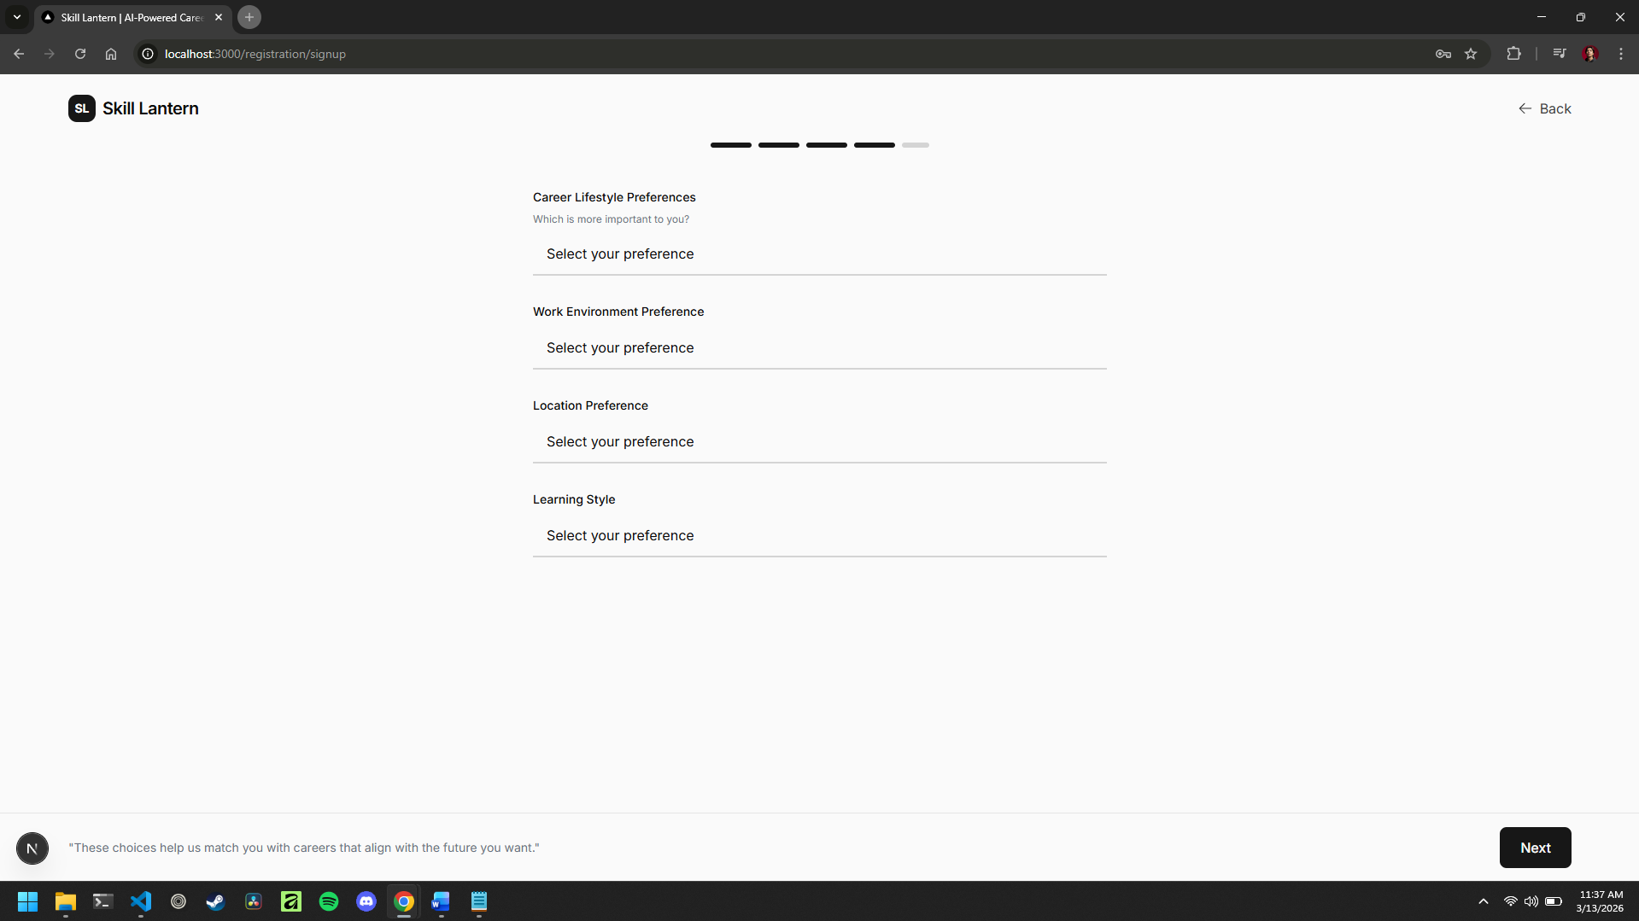
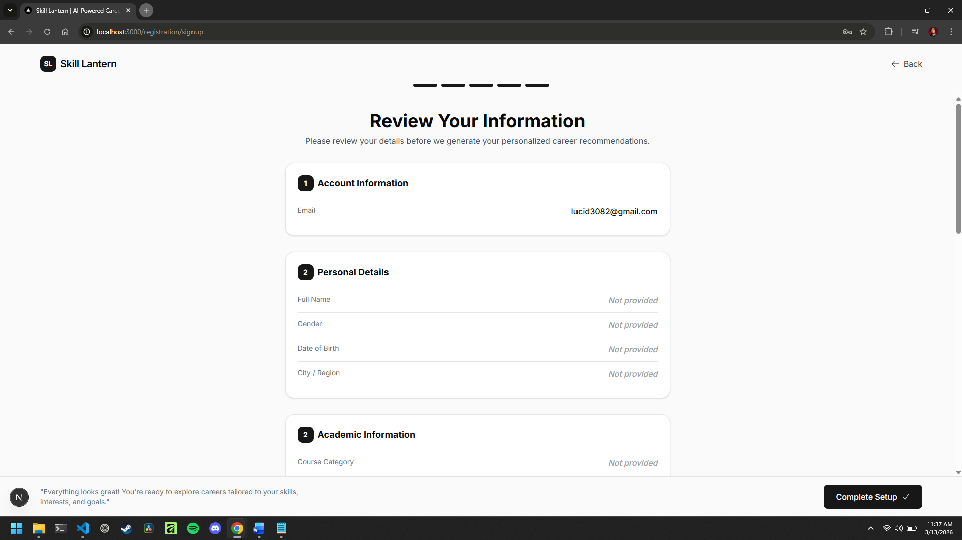
Login Page:
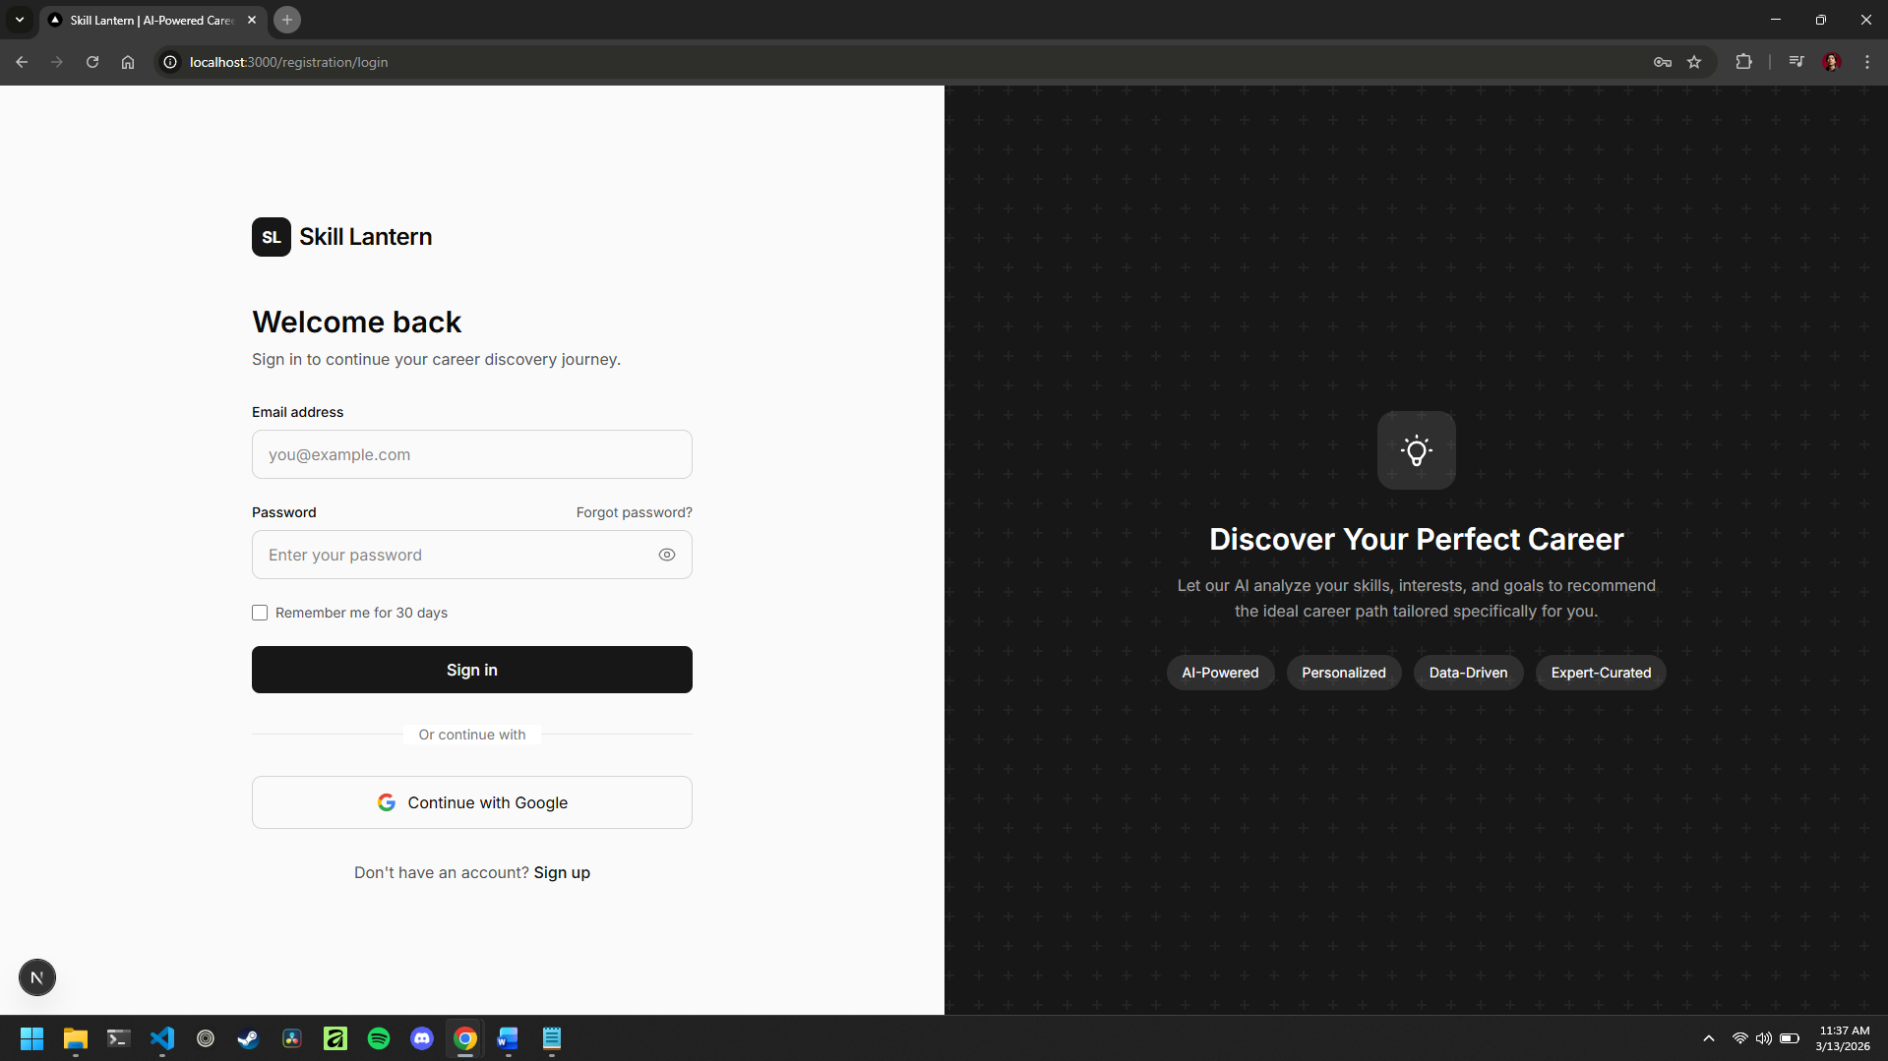
Dashboard Page:
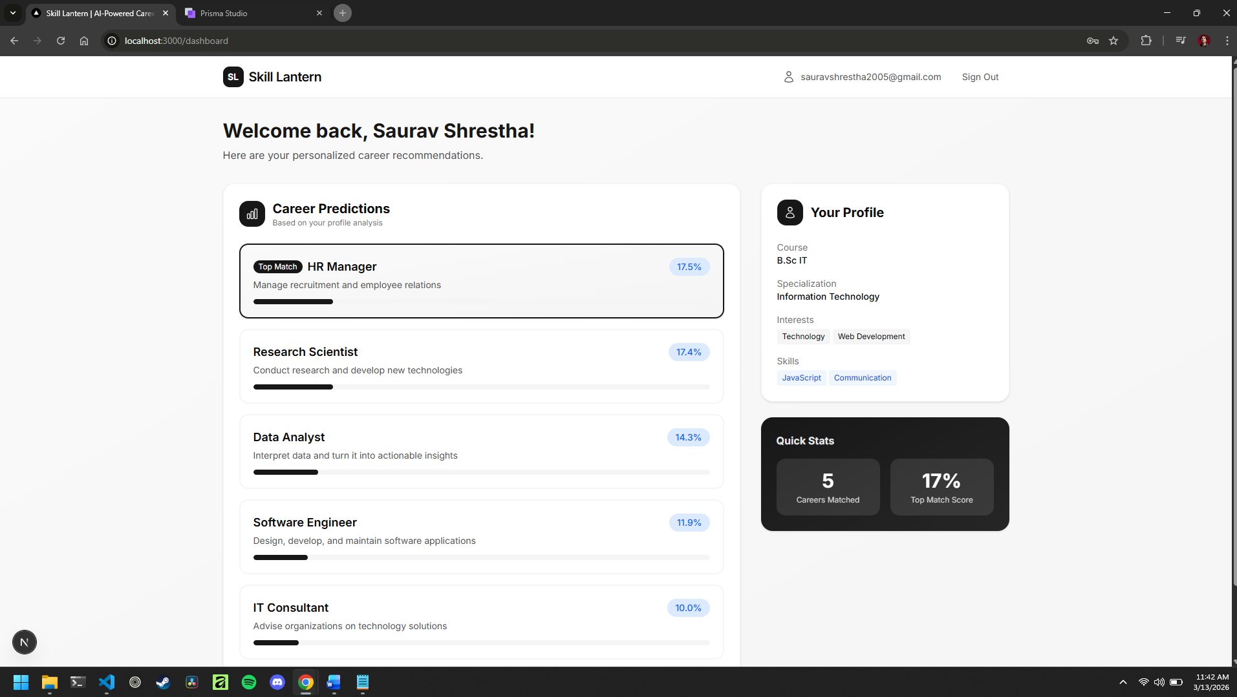
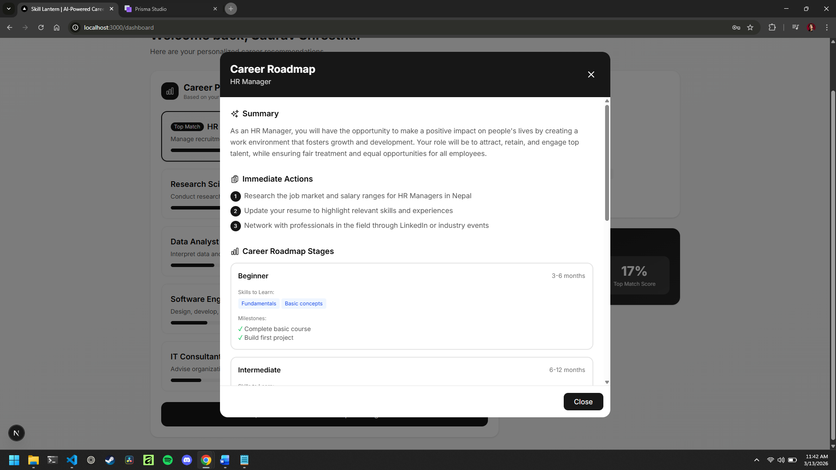
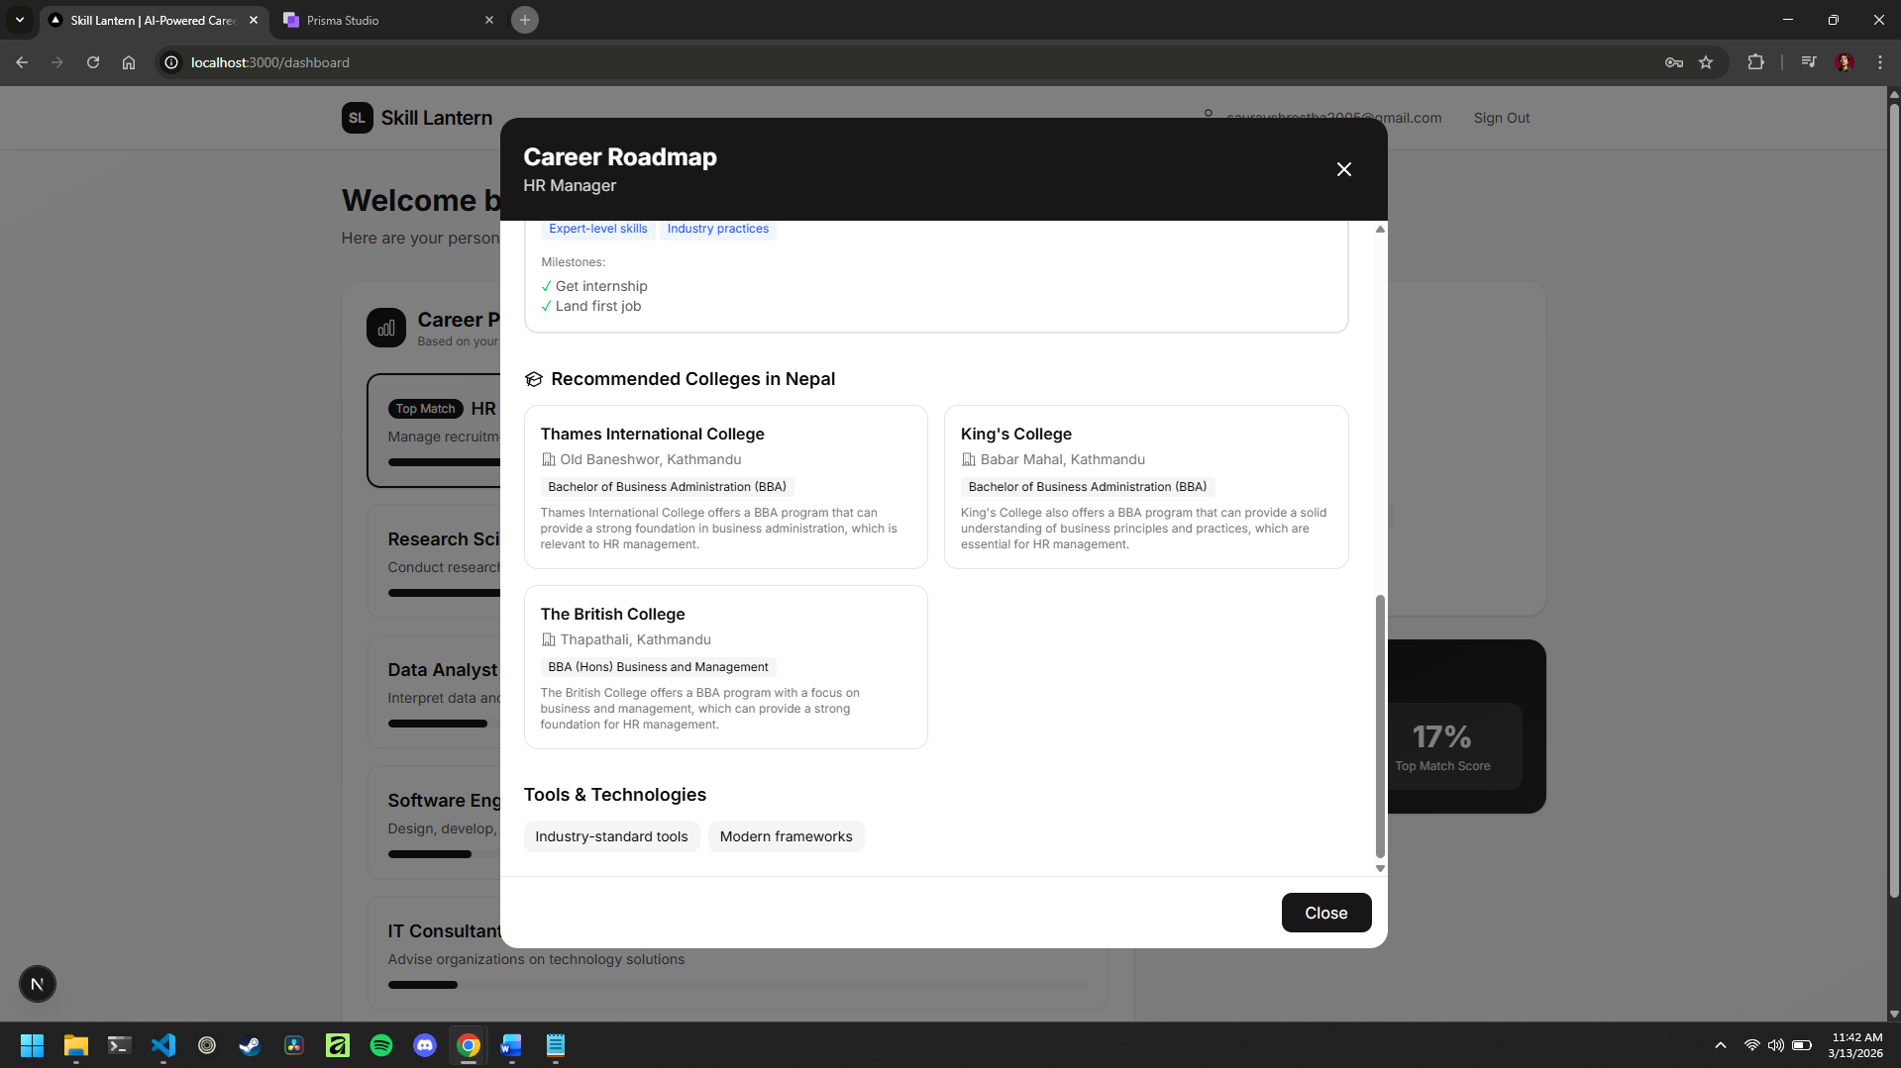

FastAPI Backend — Swagger UI:
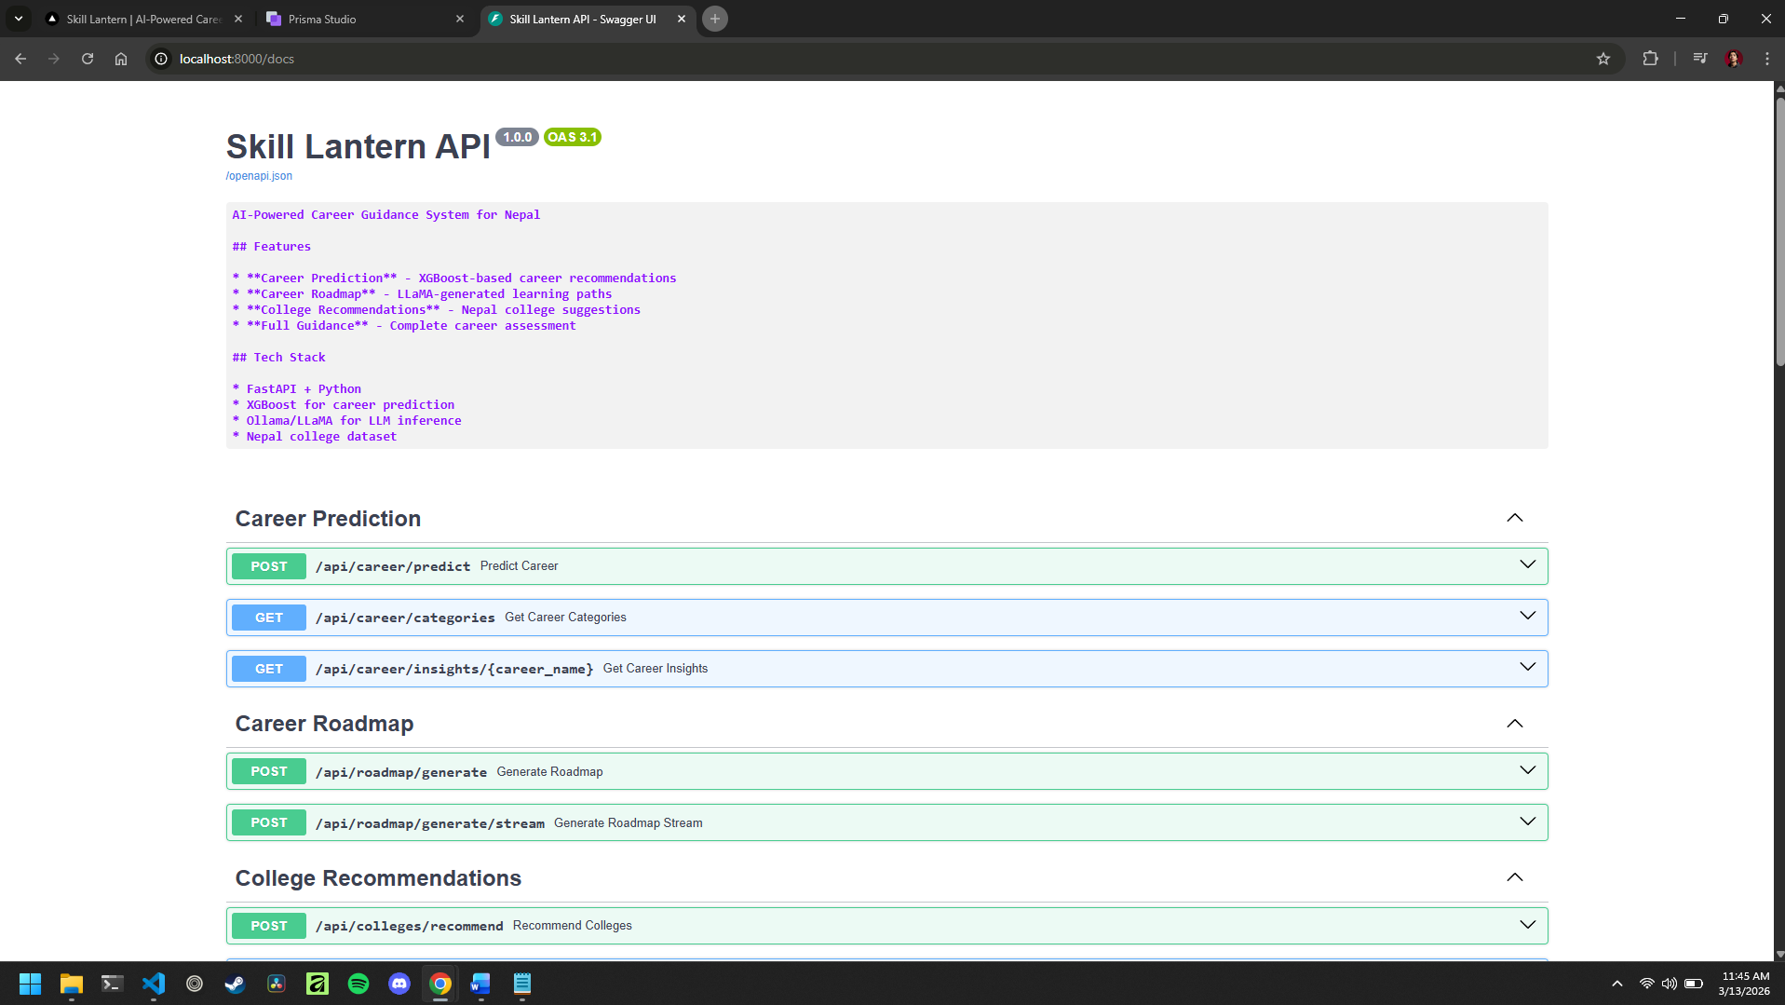

Challenges Faced
Several technical and project-management challenges have arisen during the mid-year period. The project mitigations emphasise robust engineering practices, careful dataset handling, and incremental integration to reduce end-stage risk.
Key challenges and mitigation actions:
- Dataset size and representativeness: The career survey dataset may not fully represent the diversity of career outcomes in Nepal. Mitigated through careful feature engineering, regularisation in the XGBoost model (L1/L2 regularisation, subsampling), and the rule-based fallback system.
- XGBoost model training and hyperparameter tuning: Iterative experimentation required to find optimal hyperparameters (500 estimators, max_depth=8, learning_rate=0.05). Addressed through systematic grid search and cross-validation.
- LLaMA 3/Ollama integration complexity: LLM responses can be inconsistent in format (JSON parsing challenges) and latency-variable. Mitigated through structured prompt engineering, response validation, and error handling with fallback messages.
- Multi-step signup form complexity: A 6-step form capturing 15+ fields required careful state management and validation. Addressed through React state management and progressive validation at each step.
- Frontend-backend integration: API route proxying between Next.js and FastAPI required careful CORS configuration and request/response format alignment. Mitigated through a stable API contract and incremental testing.
- Ollama resource requirements: LLaMA 3 requires significant RAM for local inference, impacting development speed. Managed by using appropriate model sizes and graceful degradation when Ollama is unavailable.

Remaining Work
The remaining work focuses on hardening the prototype into a robust demonstrator, completing quantitative evaluation, and producing final deliverables and documentation.
- Complete comprehensive XGBoost model evaluation: confusion matrices, cross-validation analysis, feature importance plots, per-class precision/recall/F1 scores.
- Improve dashboard UI responsiveness across different device sizes and resolutions.
- Enhance LLaMA 3 prompt engineering for more consistent and higher-quality roadmap generation.
- Add more detailed error handling and user feedback for edge cases (e.g., Ollama timeout, unusual profile data).
- Implement additional quality-of-life features on the dashboard (e.g., ability to regenerate recommendations, compare careers).
- Conduct user acceptance testing with target users (Nepalese students) for usability feedback.
- Complete the final project report with full evaluation results, plots, and analysis.
- Prepare project presentation and demonstration materials.

Timeline for Completion (Gantt Chart)
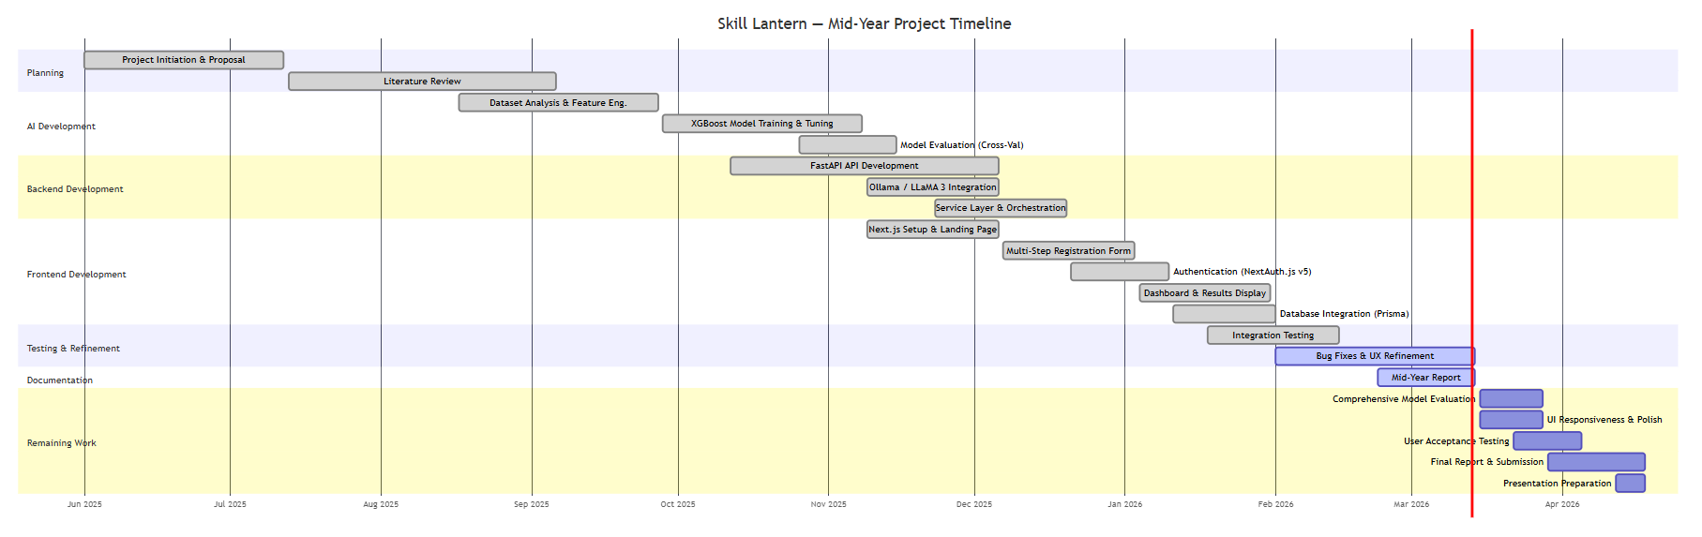

Risk Assessment and Mitigation
The project risks below summarise the most significant technical and delivery threats identified at mid-year and the mitigation strategies planned.
Risk | Impact (H/M/L) | Mitigation Strategy
Dataset limitations and weak generalisation | High | Use stratified cross-validation; apply regularisation; implement rule-based fallback; document limitations transparently.
XGBoost model overfitting on small dataset | High | Apply L1/L2 regularisation, subsampling (0.85), and max_depth constraints; use 5-fold cross-validation for evaluation.
LLaMA 3/Ollama unavailability or slow responses | High | Implement graceful degradation; add timeouts and error handling; provide static fallback messages when LLM is unavailable.
Integration complexity across frontend, backend, DB, and LLM | Medium | Maintain stable API contracts; incremental integration testing; modular service architecture.
Technical debt accumulation | Medium | Scheduled refactoring; consistent coding standards; TypeScript/Pydantic type safety enforcement.
Schedule compression near submission | Medium | Front-load evaluation and integration; maintain weekly milestones; reduce scope if required.

Supervisor Meetings Summary
Supervisor engagement has been maintained throughout the mid-year period to ensure alignment with objectives, scope, and evaluation expectations. Meetings were used to review progress artefacts, identify risks, and prioritise the remaining work for the final phase.
Number of meetings attended: [FILL IN - e.g., 8]
Number of feedback received: [FILL IN - e.g., 3]
Number of actions taken based on feedback: [FILL IN - e.g., 3]

Self-Assessment
Progress: On Track. The project has completed the foundational phases of research, requirements definition, and system design, and a working prototype has been implemented across the XGBoost model layer, FastAPI backend services, Next.js web frontend, PostgreSQL database integration, and Ollama/LLaMA 3 integration. The remaining work is substantial but achievable within the semester timeframe, with a focused plan for comprehensive model evaluation, UI refinement, and documentation.
Confidence: Medium-High. The core architecture and integration are in place the hybrid AI pipeline (XGBoost + LLaMA 3) is functioning, the full-stack web application is operational, and all major features are implemented. The final outcome depends on completing robust model evaluation, ensuring consistent LLM-generated outputs, and polishing the dashboard UI. These risks are explicitly planned for in the remaining timeline.
Reader Comments:

Declaration: I confirm that the work reported above is my own and accurately reflects my project progress to date.

Student Signature: ________________________ Date: ________________________

